HEA/JISC Open Educational

Resources Case Study: Pedagogical development from OER practice

Title: Examples and Issues in OER Use and Reuse

Author(s): Chris Follows, Anna Gruszczynska, Ming Nie, Joanna Wild
,
Institution: University of Arts London, Sheffield Hallam University, University of Leicester, University of Oxford

Outline

The case study is developed on the key findings from four projects funded by SCORE between September 2011 and May 2012. Each project focused on a specific aspect of OER use and reuse in Higher Education (HE) in the UK.

EVOL-OER aimed to develop a deeper understanding of the reuse of OERs by academics in Higher Education institutions. The project developed an ‘OER-Enhanced Curriculum’ framework which maps curriculum design against OER design and captures four different types of enhancement which can be achieved during curriculum design and delivery stages.

OER-related accessibility issues and their relevance to practices of repurposing/reuse explored issues specifically to do with accessibility of OERs. The project aimed to develop a deeper understanding of the barriers and challenges faced by academics in creating, using and reusing OERs.

OER engagement study looked into the ways in which the barriers to OER reuse can be removed with timely support from institutional support services. The study focused on creating a developmental model of engagement with OER reuse amongst academic staff.

Open online practice: developing and stewarding sustainable OER content communities focused on institutional approaches for promoting OER and Open Educational Practice (OEP). The project offered two contrasting models for embedding an OEP culture within one institution.

The key findings and lessons learned from the four projects are reported under four themes in this case study:
- Examples of OER reuse by academics
- OER engagement ladder: a developmental model to support teachers’ engagement with OER
- Open Educational Practice (OEP)
- Challenges faced by OER creators and users

Case Study

Below we shortly report on the research methods selected by each project:

EVOL-OER used qualitative methods for doing the research. Data were gathered through semi-structured interviews with twelve academics in HE institutions who had extensive experience in reusing OERs. Ten of the interviewees were from UK-based institutions. Two interviewees were from overseas institutions – one in South Africa, one in Nigeria. In addition to the interviews, analysis of examples and case studies from the OER Africa site (http://www.oerafrica.org/) was conducted as part of the research. Analysis of the interviews and online case studies provided a variety of examples of how academics reused and repurposed OERs in different ways for curriculum enhancement. These examples are included in the section ‘Learning from OER’.

EVOL-OER identified a number of drivers for OER reuse, such as a vision of the benefits of sharing, improving the quality of teaching material, increasing reputation, opening up new pedagogies and approaches for teaching and learning, and access to resources which were previously not available. There were mixed feelings about whether reusing OERs could save time, with a perception of a huge benefit in terms of saving time from some academics, whilst others considering reuse time-consuming.

A list of issues were identified by EVOL-OER as the barriers for OER reuse, including a lack of technical skills in staff, copyright and licensing issues, a lack of a culture of sharing, a lack of resources in some subjects, technical issues such as difficulties in searching and formatting, localisation, and a lack of support. This indicated that the development of digital literacy skills, and skills related to open educational practices in staff is critical for OER to be taken up at an institutional level. This should be addressed through an institution strategy for the provision of sufficient and systematic support and training to staff members and for the development of an open culture and practice.

OER-related accessibility issues and their relevance to practices of repurposing/reuse project started with a scoping exercise, which focused on ways in which UK OER projects addressed issues of accessibility. The results of that review indicated that there is the need to explicitly address accessibility issues at the early stages of project planning and resource creation, given that retrofitting is costly both in terms of time and resources.

Following the review, a series of interviews was undertaken with experts in the area of accessibility and/or OERs. The interviews revealed two approaches for addressing the accessibility issues. Making reasonable adjustments and negotiating the expectations of the learners was one approach recommended. A bottom-up strategy, for instance, rely on social networking tools to flag up resources which are accessible was suggested as another approach.

Finally, these expert consultations informed the design of a survey which targeted education practitioners. The feedback from 94 respondents indicated the importance of increasing awareness of teaching professionals of OER-related accessibility issues and providing adequate support to staff members from the institutions. Importantly, accessibility issues should not be discussed in isolation from other OER-related issues such as copyright or academic practices related to sharing resources. These issues should be approached in a more holistic way where learners and resource creators collaborate to ensure that the teaching materials best meet relevant accessibility criteria.
At the same time, the approach calls for pragmatism and recognition that it is impossible to produce a universally accessible resource, hence attention should be paid to providing resources in formats, which are easily customisable and adaptable to the needs of learners.

OER engagement study investigated the ways in which higher education institutions, individual faculties and support staff are trying to raise academic staff’s engagement with reuse of OER. The study was exploratory in nature and adopted qualitative approach to data collection and analysis. Data were collected from three groups of practitioners representing six UK higher education institutions: i) providers of OER engagement initiatives (10) ii) lecturers who participated in ‘OER training’ (5) iii) lecturers with staff development role in their faculty (3). The interviews were on average an hour long and were divided into two main parts: i) traditional semi-structured interview with a sequence of themes and questions to cover ii) an interactive activity by which the participants were asked to describe steps to optimal engagement with OER reuse, barriers one was likely to encounter on the way, as well as support mechanisms to help move the engagement forward. They did it by choosing relevant descriptors from four sets of colour-coded cards and placing them on a drawing of a ladder, which was used as a metaphor to describe OER engagement on three levels: low, middle, and high. The initial descriptors were extracted from the OER impact study data but they were not ‘set in stone’. The participants were encouraged to question, change, remove or add new cards to the entire set of descriptors. This activity was designed to shed some light on two questions:
- What is the optimal engagement with OER reuse in view of different stakeholders and what are the intermediate steps?
- How can engagement be sustained/nurtured?
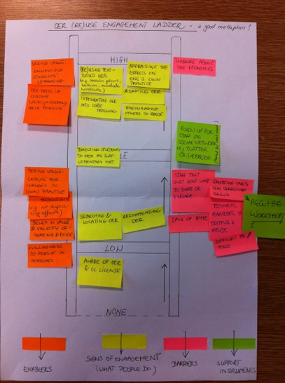

Figure 1: Example of a ready ‘OER engagement ladder’ from one of the interviews

All interviews were audio-recorded. The data from the first part were analysed using TAMS analyser – open source software to support qualitative data analysis, whereas data from the interactive activity were analysed using pen and paper technique. The data coming from the providers were analysed separately from the data coming from the teachers but the results were brought together into one visual representation to allow the emerging interrelationships and patterns to surface.

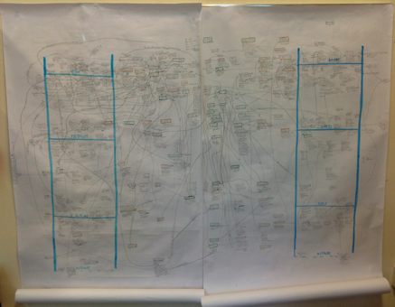

Figure 2: Pen & paper technique used to analyse the interactive activity

The study identified a number of ways in which institutions, departments or individuals are trying to raise engagement with OER reuse amongst teachers: from writing OER into strategic documents and embedding it in a variety of existing systems and services where appropriate; through getting a certain level of buy-in on the part of senior management staff in the faculty, which then makes implementation of the OER promotional activities easier; to a number of grass roots initiatives on the part of enthusiastic staff developers, learning technologists and other staff, whose roles lend themselves to promoting OER. As anticipated, bottom-up initiatives are predominant at the moment; however, those who implement them recognise the limitations of the approach and are already working on trying to get buy-in from the top to maximise the impact.

The study has shown that with or without the buy-in from the top, engaging key stakeholders i.e. support staff who work directly with academies, is a key priority for anybody wishing to raise engagement with OER amongst academic staff. This will allow for ‘natural embedding’ of OER into the current staff development services. The examples from the OER engagement study include: embedding OER in PGCert in HE as you’re “starting to catch every new member staff coming in”, offering subject-specific OER workshops as part of staff development programme but also “talking about OER in all the other workshops” because “openness, sharing, all that kind of things, it’s just something you can incorporate into other things, and last but not least, bringing OER to teachers’ attention at the point when they are in the process of designing a new course.
The aims of the ‘open online practice: developing and stewarding sustainable OER content communities’ project were to gain insight and overview of the current OEP culture at UAL and across the art & design sector and then to develop understanding and resources to support future OEP within this sector from multiple perspectives including institutional, local and national.
Feedback and stories through ‘doing’ open online practice
The key tool used throughout the project was http://process.arts.ac.uk/ a grass roots web2.0 open educational environment for sharing day-to-day arts practice and research of staff and students. Between July 2011 and June 2012 Chris Follows SCORE fellow used process.arts as a tool to steward, support and develop open educational practice at UAL and across the wider sector through the development of subject specific content/interest communities.
Conferences, workshops, focus groups and surveys exploring practices & attitudes
Chris gathered feedback and data through various internal institutional systems and processes, leading discussion and debates around the issues surrounding open practices at events such as the Learning studio a face-to-face self help workshop meetings, focus groups, consultations with staff and students, online surveys, social media networks and national and international conferences/events.
Chris integrated project research into new and existing JISC Projects; throughout the project and was involved in the bid process, development, activities and collaboration with the following projects:
UK OER Phase 2 – ALTO project & UK OER Phase 3 - ALTO UK
DIAL project –JISC/UAL digital literacies project ‘Digital Integration into Arts Learning’ (DIAL) project.
OEP PG Cert unit – JISC/UAL developing a CPDF Open Academic Practice Unit.
Open online practice was measured in site/resource use/reuse, user attitudes and voluntary open activity. Data was gathered throughout the project, new tools and processes were tested and as a result and OEP resources, communities, stories and case studies were produced and published on process.arts http://process.arts.ac.uk/category/project-groups/score.

Learning from OER

Examples of OER reuse by academics
In this section, we provide examples of how individual academics reuse OERs to enhance curriculum. The examples were identified by EVOL-OER, and structured by using the project’s ‘OER-Enhanced Curriculum’ framework (see Figure 1 below). The framework maps curriculum design against OER design and categorises four types of enhancements which can be achieved during curriculum design and delivery stages, namely rapid enhancement, panned enhancement, low-cost enhancement and strategic enhancement.

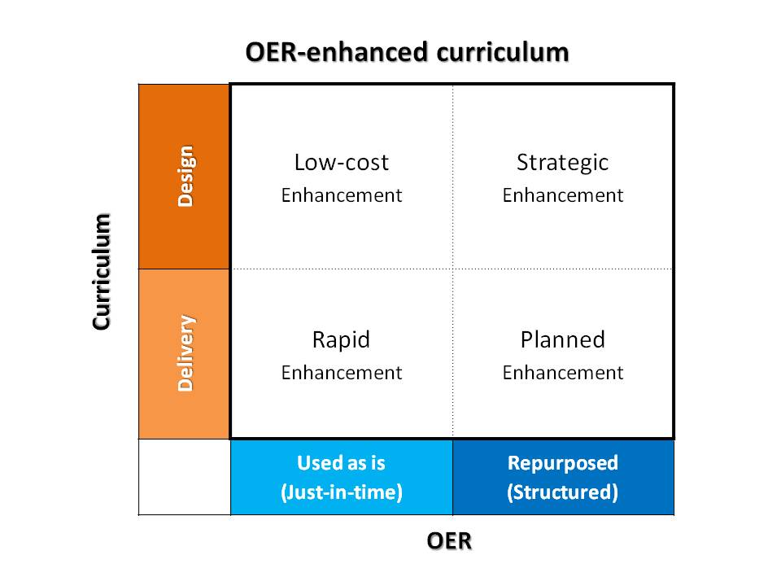
Figure 1: OER-Enhanced Curriculum

Rapid enhancement
In this quadrant, the delivery of a particular teaching session is enhanced by reusing OER. Academics working in this quadrant tend to reuse an OER ‘as is’ by either embedding it or providing the link to the OER in their teaching material. Their reuse is likely to be one-off or for a couple of teaching sessions rather than for long-term enhancement.

Example: PL teaches Sociology at a university in the UK. She frequently used YouTube videos and TV documentaries (both are OERs) to update and maintain the currency of her teaching material. The links to videos and TV programmes were usually provided in her presentation slides, used and played at a particular teaching session.

Planned enhancement
In this quadrant academics reuse OERs for the same purpose as those in the rapid enhancement, but the OERs are tweaked or repurposed to some extent to make them more suitable for the teaching context rather than just being reused ‘as is’.

Example 1: GC works for the Staff Development Unit at a university in South Africa. Her role involves promoting open content, openness and sharing across her institution. She delivers workshops and seminars to staff members from different faculties and recommends OERs which the faculty members can draw on. Part of her job involves searching for and finding OERs in different subject areas, and compiling all these resources in a presentation which she gives to the faculty members. She used many OERs to develop her presentations. One thing she did quite often was to localise these OERs to make them more suitable and specific to the African context. She also reused her own slides or slides created by her colleagues quite often. When delivering a presentation to a new group of staff, she remixed content taken from various previous presentations (which are OERs), and supplemented them with new content.

Example 2: JG is a lecturer in Law who works for a university in the UK and PJ is a lecturer in Criminology who works for a Further Education College in the UK reused OERs to support their teaching. These OERs were embedded in their teaching materials without any change, but the lecturers provided some “wrapping” information to these OERs, such as guidance for their students to know about the context and relevance of the OERs to their course, and how the students could use the resources for their study.

Low-cost enhancement
In this quadrant, OERs are embedded in the curriculum design at minimum cost. The purpose of embedding OERs in the curriculum is for long-term enhancement rather than just for supporting certain teaching sessions.

Example 1: The Bridge to Success (B2S, http://b2s.aacc.edu/) project developed two open courses: Learning to Learn and Succeed with Maths. The courses aimed at helping adult learners in the USA to successfully transit into college environment. The course content has been embedded in a wide range of courses and programmes offered by a number of partner colleges in the USA. The B2S content has been delivered in face-to-face, online or blended teaching. Data gathered from the pilot stage showed that the partner colleges have used B2S content in different ways. Some used all the content in its entirety. Some picked and used certain units from the two courses, but the units they chose to use remained unchanged.

Example 2: JL works for the English Language Teaching Unit at a university in the UK. His unit teaches many in-session students. They are the international students who are already enrolled in their degree programmes but want to enhance their English in terms of academic writing. He started using open research articles (which themselves are OERs) to demonstrate the students what constitutes academic writing. He took sections out of an open research article and used those sections exactly as they were in his teaching material. He felt that reusing these articles ‘as is’ maintained the integrity and authenticity of the material, which is very important for language teaching and learning. Some of the articles were slightly modified to make them more suitable for teaching purposes. For example, keywords were taken out from a paragraph and students were asked to put those words back in during a teaching session.

Strategic enhancement
In this quadrant, OERs are embedded in the curriculum design formally in a structured way. The academics working in this quadrant tend to repurpose OERs for the development of an open course, an open textbook, or a set of open resources, which then become the core resources for others to reuse.

Example 1: VR teaches subjects in Health Sciences at a university in the UK. She was involved in developing a new course on Laboratory Skills by reusing and repurposing OERs from a range of repositories. This course will be used for teaching lab skills to the first-year students in Health Sciences within her institution from September 2012. The course will also be used by second and third year students for reviewing lab skills in their own time.

Example 2: The Bunda College for Agriculture in Malawi developed a Communication Skills textbook by repurposing various open resources. This textbook OER has been formally embedded in the institution’s curriculum. The textbook has been subsequently reused and adapted by the University of Jos in Nigeria for the development of their own Communication Skills textbook for trade union leaders. This new textbook included sections taken from the original textbook and used ‘as is’; sections modified from the original textbook, for instance, replacing examples with trade union specific scenarios and examples; and new materials adapted from other open sources.

The ‘OER-Enhanced Curriculum’ framework has been incorporated in the Carpe Diem (http://www.le.ac.uk/carpediem) learning design workshops developed by Leicester to guide academics to think about how to use and reuse OERs to enhance curriculum design and development. The framework together with its associated examples could also be used to enhance OER utilization across other institutions.

OER engagement ladder
The major outcome of the OER engagement study is a model to promote engagement with OER reuse amongst academics. The model uses ladder analogy to describe the steps that academics are likely to take when they get engaged with OER and gradually move this engagement forward, the barriers they are likely to encounter on the way, and the kinds of institutional support they might need to help them move up on the ladder.

The model represents four major levels of engagement with OER reuse and three major turning points that bring a person from one level to another.

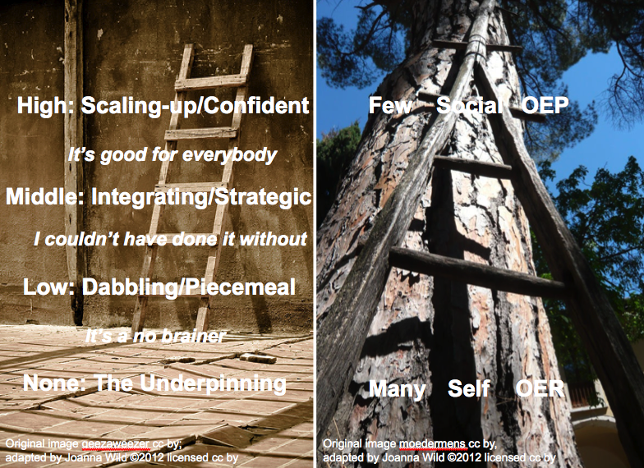

Level of engagement: None (The underpinning)
This level describes sharing and reuse-related practices that academics had adopted long before the concept of OER has emerged: a) sharing and reuse of educational resources locally or within existing communities of practice c) using digital resources found on the web to enhance teaching and learning, d) directing students to online resources as supplementary material.

Turing point 1: ‘It’s a no brainer!’
The first step into any form of engagement with open educational resources is awareness of OER and cc license followed by an understanding of the benefits for the teacher and for the learners and a reassurance that using OERs is good practice and is encouraged by the institution.

Support: a) discuss benefits, b) show examples of how other (trusted!) people use OER, c) reassure teachers that it’s good practice.

Level of engagement: Low (Dabbling/Piecemeal)
A person starts searching for OER but the ways in which they go about searching and reuse educational materials remain largely unchanged i.e. OER is used alongside ‘free stuff on the web’ usually to ‘fill in gaps’ in own teaching materials or as supplementary resources for students. A person at this level is also more likely to reuse OER produced locally or recommended by trusted people such as learning technologists, staff developers, and librarians.

Enabling factors: a) realistic expectations as to what is available ‘out there’ in one’s own discipline, b) existence of a local OER repository, c) networks of trust
Support: a) provide bespoke training and support in locating OER, b) capitalise on existing networks and informal communities by providing technical solutions to facilitate discipline-specific sharing, passing on, and clustering of resources.

Turing point 2: ‘I couldn’t have done it without!’
A breakthrough in a teacher’s engagement with OER is likely to come when they get involved in the process of designing an online course. What teachers often realise at that point is that creating everything from scratch is either far beyond their capacity, or they have to reconsider the types of materials they have used so far.

Support: Concentrate your efforts of raising engagement with OER around module teams, as you are likely to get more attention if what you’re offering is of direct relevance to what teachers are working on at the moment. Don’t treat OER as a goal itself, but as a means to an end: a better and more engaging course.

Level of engagement: Middle (Integrating/Strategic)
At this level there is a shift in a teacher’s approach to searching for and reusing OER. Searching becomes more targeted and often moves outside a comfort zone of the institutional repository. OERs are still used as supplementary materials but some get integrated into core teaching and learning. At this level of engagement teachers would usually start taking advantage of the cc license by making small adaptations (tweaks) to the resources they plan to use in their teaching. Also attributing materials to their original authors is now common.

Enabling factors: a) knowing where to search for OER, b) support in locating relevant OER, c) small granularity of resources and support with fuller adaptations, d) understanding cc by and the implications of other types of license for reuse, e) space and time to experiment

Support: a) raise OER awareness by embedding the topic into existing staff development offerings, but capitalise on the interest you might have risen by offering teachers time, space and bespoke support to investigate this topic further, b) involve librarians in sourcing and pre-selecting OER, d) develop templates to guide searching and quality appraisal, d) double-check on licensing terms and attribution until you feel they’ve got it.

Turning point 3: ‘It’s good for everybody!’
If a teacher feels positive about the effects that using OER has had on their practice and students’ learning experience, they are likely to use more of it or even share their own resources as OER. At that point a teacher starts paying attention to the legal use of 3rd party materials included in into their own OER, favouring cc license over ‘free stuff on the web’.

Level of engagement: High (Scaling-up/Confident)
At this level OER is fully embedded into a person’s teaching and learning practice and, as a result, it gets incorporated into students learning more widely and with confidence. There has also been a major shift in a teacher’s perception of who should benefit, from the initial focus on self-benefit and the benefit to one’s own students, to the benefit to the entire community, which manifests itself in a teacher’s engagement in: a) sharing own resources under open licenses, b) sharing back and commenting on resources one has modified and reused, and ii) advocacy of OER and open practice.

Enabling factors: a) sharing back and pedagogic dialogue around OERs are more likely to happen within smaller, discipline-specific networks and communities, especially if there are technical solutions at place to facilitate seamless sharing, aggregation of-, and discussion around resources, b) evidence-based knowledge about the benefits and drawbacks of reusing educational materials on a larger scale, including students’ perceptions on that.
Defining open online practice and how can we bring about changes in belief and attitude?
It’s important to understand existing cultures before introducing new cultures. It’s easy for educational developers or OER specialists to lose touch or truly understand the needs and practices of its stakeholders.
The role of open technologies in encouraging sharing and reuse of open content can only become a reality if the open technologies are being developed with and for the stakeholders involved. There cannot be one OEP to suit all, there's four, which one are you?
4 categories of open educational practice OEP, from focus group meetings, general feedback, observation and research. Also see D.White, Oxford, visitors and residents (accessed April 2012)
OEP unaware (Novice) | OEP aware (visitor) | OEP starter (lodger) | OEP resident
Never heard of or know what open educational practice is, not sure how it relates to them. | Interested in the notion of practicing or being online as a professional, happy to learn more & observer others. Look and use online resources regularly with little awareness of OERs and not does not produce or contribute their own OERs. | Has been involved and interested with online activities but now starting to explore the new potential of open educational practice and OERs. Start to create online resources with creative commons licenses, still searching for the ideal place to settle, live and practice OER and OEP. Will have many homes. Keen to understand more about the open movement and creative commons. | Posts and comments OER content daily. Has one main 'permanent' online professional/educational community domain (OER home) but uses various commercial social/rich media channels to feed, promote, debate and find OERs, a combined (Edu/social) space. Contributes to the OER community and supports others in OEP personal and professional development. Interested in wide variety of OER subjects and not only their specialist subjects but also the multidisciplinary possibilities.
Open online practice
There are two possible levels to open practice in the creative sector, as the teaching/technical staff are all teacher/practitioners. As in Shreeve’s (2008) five categories of practice. ‘Transitions: variations in tutors' experience of practice and teaching relations in art and design’, above we can see how all these different categories of practice can have an impact on the relationship of teaching practice and professional creative practice and the notion of open online practice adds a third layer of complexity to this already complex list of categories and definitions of practice.
This table (see link) illustrates how openness in practice may inevitably include both educational practice and professional practice if its to prosper, this would present wider implications for moving towards open practice and the relationship of open practice with profession and employability. This may also see a move away from the definition of open educational practice (with a focus on education) towards a combined catchall definition of OPEN ONLINE PRACTICE.
Project/institution case studies

Creating OER and OEP friendly web environments and open communities to encourage sustainable Open Online Practice

At University of the Arts London I had the fortune of working closely with phases 2 and 3 of the JISC UKOER programme on ALTO project where I gained first hand experience of how an institution develops an OER repository system. In parallel with this I was developing the process.arts web environment and communities through my SCORE fellowship. Contrasting the two approaches I have summarized below what I see as the distinct differences between the two and I would argue that many forward-thinking universities may benefit from the inclusion, early planning and adoption of a sustainable OER eco systems which includes ‘in-house’ development projects, grassroots innovation, developers and webmakers, specifically working with true open source software and up-to-date web2.0 environments.

ALTO UAL developed its repository (Filestore http://alto.arts.ac.uk/filestore/ ) using Southampton’s ePrints software. Process.arts had already been in development for over a year prior to the ALTO project and funding. Process.arts was an on-going live agile experimental education/social OER web project and as the ALTO developed it was acknowledge early in the ALTO planning that process.arts provides a valuable informal ‘social community OER layer/platform’ currently missing from conventional repository system.

The ALTO ecosystem
The project started with a strong focus on acquiring and installing digital repository software to handle the completed OERs. The repository software package 'EdShare' was chosen, a variant of the popular research paper repository 'Eprints' supplied by Southampton University. Repository software is optimized for storage and management and operates using a library paradigm - which is great for that particular purpose, but is not so good at presenting or publishing information. The presentational limitations of repository software became apparent in the context of ALTO and the Art and Design academic community.
The 'Eprints' system although promoted as an ‘out of the box’ solution and ‘open source’ system in reality is a more complicated, restrictive and difficult to manage and develop ‘out of the box’ for most HEI in-house web teams. All users of 'Eprints' I spoke to admit the software was restrictive (in an agile development sense) the code was too complicated (specialised) for an in-house team to truly adopt and adapt. The ‘enforced’ reliance of a contracted service for me cast serious doubt on the sustainable development and future of OER repositories running on theses systems. Also see ALTO project manager John Casey’s perspective on these older repository systems http://process.arts.ac.uk/content/open-practice-stories#comment-1805.
OEP platforms: process.arts combines institutional support & grass roots activity for developing sustainable Open Educational Practice
http://process.arts.ac.uk/, a grass roots web2.0 open educational environment for sharing day-to-day arts practice and research of staff and students, currently provides a new ‘open learning’ space to the University of the Arts London (UAL) that straddles the institution/educational (formal learning) environment and the social (informal learning) environment. It creates an ‘experimental’ space for open educational practitioners to develop and define a new language for open edu-social practice without conforming or being influenced by pre-existing academic structures and processes. The transition of process.arts into an official UAL service will test this model and raise questions as to how institutions successfully support and develop autonomous and independent grassroots innovation without homogenising innovation. Read more about process.arts.
True open source in-house development
Various UAL individuals and departments are developing drupal and open source projects these include, student developers working on http://process.arts.ac.uk/ , the site was initially developed by UAL in-house developers, and development continued or was taken over by teaching staff and student developers who practiced as in-house drupal developers. UAL has since launched ‘drupal UAL’ in-house community of practice for student and staff webmakers to explore and gain skills in drupal development http://process.arts.ac.uk/category/project-groups/drupal-ual.
In 2012 UAL began the process of rebuilding its VLE framework, and process.arts was identified as a valuable resource that could fit into the University’s new portfolio of tools; consequently, process.arts is due to be officially introduced as a supported ‘service’ in September 2012.
However, the structure of process.arts does not map onto courses; meta data links user-generated pieces of openly licensed text, image, video and audio content together through individual profiles and subject specific interest groups. Like many web2.0 environments used for education, process.arts can neither really be described as a repository nor as a VLE. Because of this it provides a novel and alternative VLE environment that encourages and supports rich media experimentation and informal learning, a welcome alternative for many to commercial alternatives.
Conversion to a full service will provide a firm foundation for long-term stability, integration with other systems, support and growth. The project team is in the process of integrating the current informal agile development approach into a more formal in-house system. The team are addressing outstanding bugs, monitoring user interface changes and identifying outstanding functionality. There will inevitably be some loss of agile spontaneity although we aim to retain the overall grass roots participatory feel.
We are currently considering the pros and cons of mainstreaming, and are continually evaluating what we would consider as a balanced approach, based on the experience of this transition to date.
OEP communities and stewardship
There is currently no middle ground within our institutional networks to facilitate the development of OER content communities. How can the proliferation of open education/social media content groups and networks support the process of cultural change and OER stewardship in these new alternative open online spaces for artists, teachers, students and practitioners?
Group and mentor development

There is some difficulty encouraging participation and interaction, the recent drawing out group (conference group) were all asked by their group facilitators to uploaded their own work to process.arts, they all did this without any problems http://process.arts.ac.uk/category/project-groups/drawing-out-2012. There was no visible presence on the group space and I feel like other groups, the lack of visible online presence or group mentor means little or no debate. In contrast this forum http://process.arts.ac.uk/content/2-or-3-things-start is starting to get comments/ interaction on its subject, because Jess and David the group/project ‘owners’ are actively online and engaged, pushing the debate forward. The important thing is that groups have a few experts or active interested members posting on the group and who are a regularly actively presence in this space encouraging, setting up debates and adding support etc. This is a core skill of being doing ‘open online practice’, its not something you can necessarily learn its something you do and keep on doing.

SKILLS | SUPPORT (HAND HOLDING) | OPEN ONLINE PRACTICE
By skills I mean those skills that can be obtained easily, the type of skills that are generic and are accessible and available to most e.g. I want to learn Photoshop, I go on a course or I search YouTube and watch a video. I want to learn MS word; I’ll go on a staff development day. | Hand holding, being able to find content and answers easily, some know where to look some don’t, information underload within the practice based art and design sector means these places for support do not yet exist. A fun example of being able to seek advice for a random problem, the problem was answered with the hour of posting: http://process.arts.ac.uk/content/metalwork-problem who’s holding our hands for the other less resourced or open subject areas? | Skills in this area are a lot more difficult to obtain. Is open online practice something you can be taught through attending a course? Or are these ‘skills’ self learnt, through embedding into practice and peer support?

Challenges faced by OER creators and users

A number of issues and challenges faced by OER creators and users were identified which will have an impact on the sustainability of OER.

Technical skills
There is a lack of technical skills in staff in using and reusing OERs. This was identified as the key factor affecting the level of modification, especially with multimedia OERs. One typical example is that some academics did not have the skills to edit a video OER. They had to either reuse the video ‘as is’ or give up on using it completely.

Copyright issues
There is a lack of understanding of copyright and licensing issues in staff. This was reported as one of the key barriers for OER reuse. Many academic indicated that using OER has challenged their years of practice, it is a totally different way of thinking, and it is completely daunting and overwhelming for a start. Some academics provided links to OERs instead of embedding them properly in their teaching material to avoid problems with copyright and licensing.
Case study: OEP and Intellectual property rights
The IPR culture at UAL as I have known it has always been dismissive of IPR policy, the general rule of thumb is ‘don’t go there’. Please see IPR UAL case study.

Availability and discovery
There is a perceived lack of OERs in some subject areas, such as Sociology, Criminology, Law, Arts and Design, and English Teaching, which presents a barrier for reuse. There is a general lack of multimedia OERs across all subject areas. In addition, many academics found that searching and finding OERs was not an easy task and was time-consuming. The process usually involved conducting search across different repositories by using the same keywords, as the OERs were all located and scattered in different places. Many found that conducting a general search via Google (with the rights filter on) was more effective and efficient than going through different repositories.

Building repositories with subject-specific OERs could help address this problem. The development of a federated search engine which pulls out all search results from across different repositories could make search much more effective. Providing sufficient “wrapping” information to the OER, such as guidance on how people can use the resource, could ease the process as well.

Accessibility issues
There is a need to increase awareness of teaching professionals of OER-related accessibility issues.
Providing resources in formats which are easily customisable and adaptable to the needs of users is very important.

Some OER creators give very restrictive license to their resources. For example, the ‘non-derivative’ clause in a licence prevents others from modifying the material in any way, and therefore, presents a barrier for others who want to repurpose OERs. The OERs should be licensed in a way which allows for easy reuse and customisation without being encumbered by copyright restrictions.

Some authors made OERs available in formats such as PDF or Flash, which other users cannot change or re-edit. Resources created in Wimba Create (or Course Genie, the previous brand name of Wimba Create), which generates html-based items, and videos were perceived more user-friendly for repurposing.

The size or granularity of the resources is important for reuse. Smaller is perceived something better than bigger, especially when the reusers are not looking for whole courses, but little bits from different places which they could incorporate into their teaching materials easily. Evidence also showed that bigger OERs pushed people away from reuse. Small, bite-sized resources were favored, especially when the purpose of the resource was to generate interest from learners.

In some cases, OER creators should be aware of difficulties involved in using rich media content by certain user groups. Therefore the provision of transcript for any audio/video material is considered very important. However this might present some inherent difficulties for managing the consistency of the content. For instance, an audio resource might be accompanied by a transcript but if the audio is subsequently altered and a new version is uploaded, then very often the transcript is not. As a result, the audio and the transcript will stop being broadly equivalent.

There is a need to address accessibility features of platforms where OERs are deposited. Education repositories should be designed with accessibility in mind given that past the point of deposit, the resource creator is no longer in control of the environment in which the material is hosted and if the repository lacks adequate accessibility features, then by default so will the resource.

There are a number of relatively simple strategies that could greatly enhance the accessibility of OERs, such as using accessibility features embedded within software packages. Tools such as the Accessibility Passport (http://www.accessibilitypassport.org) and the Xerte Online Toolkit (http://www.nottingham.ac.uk/xerte/toolkits.htm) should be promoted more widely within the institutions, as they enable users to create teaching materials where accessibility is embedded from the very beginning of the content creation process and so costly retrofitting can be avoided.

Another recommendation is that creators should use metadata accurately so that it is easy to locate accessible practices. As part of that description, content creators could also inform potential learners if something is not accessible so that they don’t have unreasonable expectations.

Support to OER creators and users
There is a general lack of support to OER creators and users from the institutions. This should be addressed through an institutional strategy for the provision of sufficient and systematic support and training to staff members for the development of OEP within the institutions. The support should cover the following aspects:

- Development of digital literacy skills in staff with regard to OER creation, use and reuse. This should focus on developing the technical skills in staff for creating and editing multimedia resources, providing recommendations to useful OER repositories and subject-specific resources, and providing guidance on how to effectively conduct OER-related search to improve search results.
- Development of deeper understanding of copyright and license issues in staff, for instance understanding how different types of licensing work and how to combine them together for OER creation and reuse.
- Provision of good practice and guidance on how to create OERs in appropriate format, size and license to make them more reusable and repurposable for others.
- Case studies showcasing the process of creating accessible OERs (including actual model examples of accessible resources) in order to illustrate ways in which the needs of diverse types of learners and users of OERs can be met. The case studies would help raise awareness about accessible e-learning practice and ideally would include recommendations for subject matter experts as well as OER support staff.
- Provision of OER-related resources which address discipline specific issues alongside more generic resources which address the needs of teaching professionals who work in cross-disciplinary contexts.

Conclusions

Institutional strategy
Development of digital literacy skills, and skills related to open educational practices in staff is critical for OER to be taken up at an institutional level. There is a need to provide adequate support in terms of technical resources, relevant institutional policies as well as guidance from learning technologists and subject specialists as and when needed.

Institutions may need to support and develop a more active and sustainable eco systems and support networks for open practice, which includes all the OEP key players unaware, aware, visitor and residents and these key players need to be identified and be involved in the agile development of the community.
Many institutions don’t have the ‘foresight’ to create their own in-house open online video archive/platforms so have to rely solely on external commercial channels like iTunes as their primary platform or video archive, this could present problems in the future.

Commercial media channels really should be secondary channels not primary. We understand the benefits of commercial channels but should colleges be putting all their eggs into one commercial basket, all videos produced by the institution should be made available and accessible at all times to everyone and be free from commercial fees, conditions and advertising. If institutions have their own in-house rich media archives and learning networks they could directly benefit from the communities built around them. In-house and externally hosted archives can also be mutually beneficial, and if sometime in the future the institution wants to withdraw from a commercial platform they can without fear of being too tied into one host and losing that all important community.

The outputs of the project indicate that accessibility is a complex issue where addressing only one part of the equation, whether it is technology, provision of resources or attitudes of academics will not be as effective as viewing accessibility in a more holistic way where learners and resource creators collaborate to ensure that the teaching materials best meet relevant accessibility criteria. Overall, accessibility issues should not be discussed in isolation from more general academic attitudes which are not always conducive towards open sharing of teaching resources.

The OER engagement study revealed that teachers need support in locating and using OER, both a the beginning of their engagement with this type of educational materials, and later on in the process, when they are ready to take this engagement forward and make OER an integral part of their teaching practice. OER should be embedded as an element within existing systems and support services but there is a need to coordinate the efforts to avoid fragmentation.

http://www.jisc.ac.uk/whatwedo/programmes/elearning/oer2/oerimpact.aspx

